# PERT CHART

Pert chart is a project management tool used to plan, sort out, and arrange assignments inside a task. It is essentially a technique to analyze the charts associated with finishing a given venture, particularly the time expected to finish each undertaking, and to distinguish the base time expected to finish the all out task.

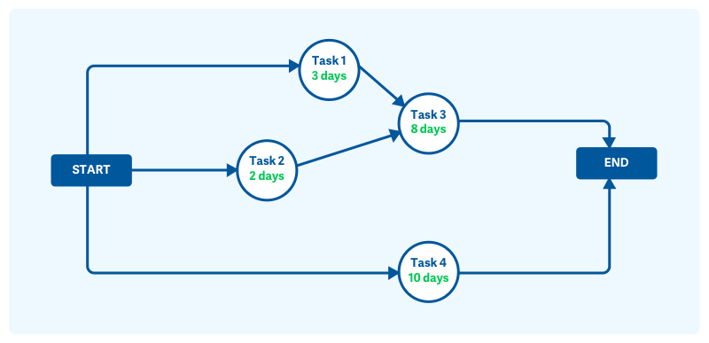

**Pert chart network diagram**

